Grade 10 IB Bridging Year Chemistry

Topic 5 Stoichiometry

**5.4 Reacting mass**

Balancing equations give a summary of the chemicals reacting and produced in a chemical reaction. The mole ratio actually tells us more than this. A balanced chemical equation will enable a manufacturer to work out the quantities required and the masses of the products that can be expected.

*For example:*

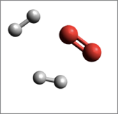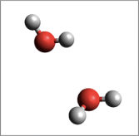

O

O

H

H

H

H

2 hydrogen molecules + 1 oxygen molecule 🡪 2 water molecules

2 moles of H2 molecules + 1 mole of O2 molecules 🡪 2 moles of H2O molecules

4g of H2 molecules + 32g of O2 molecules 🡪 36g of H2O molecules

*Mass of all reactants = Mass of all products*

*Another example:*

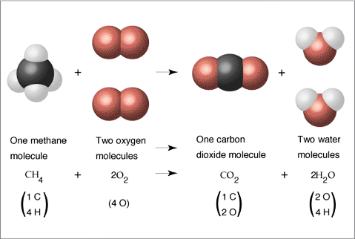

____ mole of methane + _____ mole of oxygen 🡪 ____ mole of carbon dioxide + _____ mole of water

______ g of methane + _______ g of oxygen 🡪 _______ g of carbon dioxide + _______ g of water

***Steps for calculating masses of reactants and products in chemical reactions:***

1. Balance the equation for the reaction.
2. Convert the known mass of the reactant or product to moles of that substance.
3. Use the balanced equation to set up the appropriate mole ratio.
4. Use the appropriate mole ratios to calculate the number of moles of the desired reactant or product.
5. Convert from moles back to grams if required by the problem.

***Example 1***



**What mass of oxygen will react with 96.1 g of propane?**

1. Determine the mole ratio from the chemical equation:

____ mol of propane reacts with _____ mol of oxygen to give _____ mol of carbon dioxide and _____ mol of water.

1. Find the number of moles of propane to begin with =
2. Using the mole ratio, find the number of moles of oxygen that will react with the calculated number of moles of propane (answer of part 2) =
3. Using the answer of part 3, calculate the mass of oxygen that reacts =

***Example 2***

Haber process is an industrial process which manufactures ammonia from hydrogen and nitrogen, in order to make fertilizers:

N2 (g) + 3 H2 (g) 🡪 2 NH3 (g)

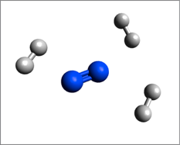 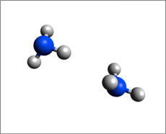

1. Complete the submicroscopic diagram for the products in this reaction.
2. Calculate the number of moles of 9.00g of hydrogen.
3. Using the mole ratio, calculate the number of moles of ammonia produced from the 9.00g of hydrogen gas.
4. Calculate the mass (in g) of ammonia produced from 9.00g of hydrogen.

***Example 3***

Solid lithium hydroxide is used in space vehicles to remove exhaled carbon dioxide from the living environment by forming solid lithium carbonate and liquid water.

_2_ LiOH (s) + __ CO2 (g) 🡪 ___ Li2CO3 (s) + ___ H2O (l)

In a space shuttle, **1.00 kg** of lithium hydroxide is stored for removing carbon dioxide inside the cabin.

1. Complete the chemical symbol equation by balancing it.
2. Calculate the number of moles of solid lithium hydroxide stored in the space shuttle.

**1000/23.95**

**41.7537**

1. Calculate the number of moles of carbon dioxide that can be removed by the solid lithium hydroxide.

20.8768

1. Calculate the mass (**in kg**) of carbon dioxide gas that can be absorbed by the solid lithium hydroxide stored in the space shuttle.

**0.919kg**

***Example 4***

Baking soda (NaHCO3) is often used as an antacid. It neutralizes excess hydrochloric acid secreted by the stomach:

NaHCO3 (s) + HCl (aq) → NaCl (aq) + H2O (l) + CO2 (g)

Milk of magnesia, which is an aqueous suspension of magnesium hydroxide, is also used as an antacid:

Mg(OH)2 (s) + 2HCl (aq) → MgCl2 (aq) + 2H2O (l)

Which is the more effective antacid per gram, NaHCO3 or Mg(OH)2?

1. Find the number of moles of 1g of NaHCO3 antacid.

0.011903 mol

1. Find the number of moles of hydrochloric acid that can be neutralized by 1g of NaHCO3 antacid.

0.011903

1. Find the number of moles of 1g of Mg(OH)2 antacid.

0.017144

1. Find the number of moles of hydrochloric acid that can be neutralized by 1g of Mg(OH)2 antacid.

0.034288

1. For each gram of the antacid, which one is more effective in neutralizing hydrochloric acid?

Mg(OH)2

***Practice Exercise***

1. Over the years, the thermite reaction has been used for welding railroad rails, in incendiary bombs, and to ignite solid-fuel rocket motors. The reaction is

Fe2O3(s) + 2Al(s) → 2Fe(l) + Al2O3(s)

1. What masses of iron (III) oxide and aluminum must be used to produce 15.0 g iron?

Mol of Fe = 0.268577

Mol of Fe2O3 = 0.134288

Mass of Fe2O3 = 21.4g

Mol of Al = 0.268577

Mass of Al = 7.2462g

1. What is the maximum mass of aluminum oxide that could be produced?

n(Al2O3) = 0.134288

m(Al2O3) = 13.692g

1. The reusable booster rockets of the U.S. space shuttle employ a mixture of aluminum and ammonium perchlorate for fuel. A possible equation for this reaction is

3Al(s) + 3NH4ClO4(s) → Al2O3(s) + AlCl3(s) + 3NO(g) + 6H2O(g)

What mass of NH4ClO4 should be used in the fuel mixture for every kilogram of Al?

n(Al) = 37.0645

n(NH4ClO4) = 37.0645

m(NH4ClO4) = 4.36 kg

1. One of relatively few reactions that takes place directly between two solids at room temperature involves barium hydroxide octahydrate, Ba(OH2) • 8H2O(s), and ammonium thiocyanate (NH4SCN).

The equation of the chemical reaction is shown below:

Ba(OH)2•8H2O(s) + 2NH4SCN(s) → Ba(SCN)2(s) + 10H2O(l) + 2NH3(g)

* 1. What mass of ammonium thiocyanate (NH4SCN) must be used if it is to react completely with 6.5 g barium hydroxide octahydrate?

n(Ba(OH)2.8H2O) = 0.020602

n(NH4SCN) = 0.041203

m(NH4SCN) = 3.14g

* 1. What masses of the three products would be produced in the reaction of part (a)?

Ba(SCN)2= 5.2227g

H2O= 3.7124g

NH3 = 0.702g